REPAIRSYNC CLOUD:
A SAAS-BASED SMART SERVICE TRACKING AND INVENTORY MANAGEMENT PLATFORM FOR ELECTRONICS REPAIR BUSINESSES

Capstone Project Presented to
The Faculty of the College of Computing & Information Sciences
Surigao del Norte State University
Surigao City

In Partial Fulfillment
Of the Requirements for the Degree
Bachelor of Science in Information Technology

By

Jeo B. Añosa
Irel Dominick L. Tandugon

May 2026
ABSTRACT
This study aimed to design and develop REPAIRSYNC CLOUD, a SaaS-based smart service tracking and inventory management platform for electronics repair shops in Surigao City. The study was conducted in response to the continued use of manual processes in managing repair transactions, customer records, repair monitoring, inventory handling, and payment recording. Manual methods often result in disorganized records, delayed customer updates, difficulty in monitoring repair progress, and inefficient management of spare parts and technician assignments.
To address these problems, the researcher developed a cloud-accessible web application that centralizes repair shop operations into a single platform. The proposed system includes modules for job order management, customer and device information recording, repair status tracking, technician assignment, spare parts inventory monitoring, payment recording, report generation, notification services, customer repair tracking, and free online consultation. The system also allows customers to monitor repair progress remotely using a job order number without the need to physically visit the repair shop for updates.
The study used the Agile Development Methodology in planning, designing, developing, revising, and evaluating the proposed system. The result of the study was a functional SaaS-based platform designed to improve operational efficiency, record organization, service transparency, and accessibility for electronics repair businesses.
The developed system is expected to reduce manual errors, improve transaction monitoring, strengthen inventory management, and enhance customer communication through cloud-based accessibility and notification features. Therefore, the proposed system may serve as a practical and modern digital solution for electronics repair shops in Surigao City.
KEYWORDS
customer tracking, electronics repair shops, repair service management system, Surigao city, SaaS-based platform.
1. INTRODUCTION
Many electronics repair shops still rely on manual processes such as handwritten records, notebooks, paper receipts, and basic spreadsheets in managing their daily operations. While these methods may still work for smaller businesses, they become inefficient as the number of customers, repair transactions, spare parts, and service requests increases. Important records such as customer information, repair progress, technician assignments, inventory usage, and payment details may become difficult to organize, retrieve, and monitor properly.
Manual processes can also cause delays in service operations and customer communication. Repair shops may experience problems in monitoring which devices are pending diagnosis, under repair, waiting for spare parts, completed, or ready for release. Customers often need to repeatedly contact or personally visit the repair shop just to ask for updates regarding the status of their devices. In some cases, incomplete records, misplaced documents, and delayed updates affect both operational efficiency and customer satisfaction.
With the continuous advancement of cloud computing and Software-as-a-Service (SaaS) technologies, many businesses are now adopting web-based and cloud-accessible platforms to improve operational management, accessibility of records, and customer services. SaaS-based systems allow users to access services through the internet without requiring complicated installation and maintenance procedures. Through centralized cloud-based platforms, businesses can manage transactions, records, monitoring, and communication more efficiently and conveniently.
As a Bachelor of Science in Information Technology student at Surigao del Norte State University, the researcher identified the need for a more organized and accessible digital solution for local electronics repair shops. This study aims to design and develop REPAIRSYNC CLOUD, a SaaS-based smart service tracking and inventory management platform intended to improve repair shop operations through centralized and cloud-accessible management tools.
The proposed system is designed to manage job orders, customer and device information, repair status monitoring, technician assignments, spare parts inventory, payment recording, notification services, online consultation, and customer repair tracking. Customers may also submit initial repair concerns remotely through a free consultation feature and monitor repair updates using a job order number without immediately visiting the repair shop.
The proposed platform is expected to improve efficiency, strengthen inventory monitoring, reduce manual errors, enhance service transparency, and provide more convenient communication between repair shops and customers.
This study seeks to answer the following questions:
- What problems are encountered by electronics repair shops in Surigao City in managing repair services manually?
- How can a SaaS-based repair service management platform improve the recording and monitoring of repair shop transactions?
- How can the proposed system improve repair tracking, spare parts inventory monitoring, technician assignment, and payment recording?
- How can notification and online consultation features improve customer communication and service transparency?
- How acceptable is the proposed system in terms of functionality, usability, reliability, and efficiency?

- Project Context
This project is developed in response to the common challenges experienced by electronics repair shops in handling their daily operations manually. Since repair shops deal with many customers, devices, and repair concerns, proper organization of records is very important. However, not all repair shops have a system that can help them manage this information efficiently.
In Surigao City, electronics repair shops are still important because many people prefer repairing their gadgets and appliances instead of replacing them right away. Because of this, repair shops need a more reliable and organized way of handling their work. The proposed project is relevant in this setting because it offers a digital solution that can help local repair shops improve their management of repair transactions and customer service.
1.2 Purpose and Description
The main purpose of this study is to design and develop a SaaS-based repair management platform for electronics repair shops in Surigao City. It aims to provide a better and more organized way of handling repair shop operations compared to the usual manual process.
The proposed system allows users to create and manage job orders, store customer and device information, update repair status, assign technicians, monitor spare parts used during repair, record customer payments, and generate reports. It also provides a customer tracking feature so that customers can check the progress of their repair using a job order number. In general, the system is intended to help repair shops become more organized and efficient in managing their services.
1.3 General Objectives of the Study
This study aims to design and develop a SaaS-based smart service tracking and inventory management platform for electronics repair shops in Surigao City that will improve the management of repair transactions, customer services, inventory monitoring, and repair tracking through a centralized cloud-accessible platform. Specifically, it aims to:
- Gather and analyze the system requirements needed for the development of the proposed Repair Service Management Platform.
- Design and develop a SaaS-based platform that can manage job orders, customer information, device records, repair status, technician assignments, spare parts inventory, payment transactions, and customer tracking.
- Develop a notification feature that can provide customers with updates regarding repair progress, repair completion, pending repairs, and other service-related information.
- Develop a free online consultation feature that allows customers to submit repair concerns and inquiries remotely without immediately visiting the repair shop.
- Provide a customer repair tracking feature where customers can monitor the status of their repair using a job order number.
- Evaluate the proposed system in terms of functionality, usability, reliability, and efficiency.

1.4 Scope and Limitations
This study focuses on the design and development of a SaaS-based smart service tracking and inventory management platform intended for electronics repair shops in Surigao City. The proposed platform includes the following features:
Scope
This study focuses on the design and development of a SaaS-based smart service tracking and inventory management platform intended for electronics repair shops in Surigao City. The proposed platform includes the following features:
- Job order management for recording and organizing repair transactions.
- Customer and device information management for storing repair-related records.
- Repair status tracking for monitoring the progress of repair services.
- Technician assignment and technician workspace for managing repair responsibilities.
- Spare parts inventory monitoring for tracking available and used repair parts.
- Part request management for requesting unavailable spare parts needed for repair.
- Payment recording and repair cost monitoring for managing customer payments and balances.
- Customer repair tracking using a job order number.
- Notification feature for informing customers about repair updates, repair completion, and repair progress.
- Free online consultation feature that allows customers to submit repair concerns and inquiries remotely.
- Report generation and dashboard monitoring for repair shop management and operational reporting.
- Role-based user access for administrators, staff, and technicians.
- Audit logging for monitoring important user and system activities.
- Cloud-based accessibility through a SaaS platform that allows users to access the system using an internet connection.

Limitations
The study is limited only to the core operational functions of electronics repair shop management.
- The system does not include advanced accounting and financial management features.
- The system does not support online payment gateways and digital wallet integration.
- The platform is limited only to web-based access and does not include a dedicated mobile application.
- The system does not support multi-branch repair shop management.
- The notification feature is limited only to repair-related updates and service notifications.
- The online consultation feature is limited only to initial repair inquiries and does not replace actual technical diagnosis inside the repair shop.
- The study is limited only to selected electronics repair shops and respondents within Surigao City.
- The evaluation of the system is limited to the available respondents, resources, and timeframe of the study.

2. RELATED LITERATURE
Recent studies have shown that web-based information systems remain important in improving organizational efficiency, accessibility of records, and monitoring of day-to-day operations. In many service-oriented environments, manual procedures such as handwritten logs, scattered spreadsheets, and disconnected reporting tools often lead to delayed transactions, incomplete records, and weak coordination. Because of these recurring problems, organizations increasingly adopt web-based systems to centralize information, support real-time monitoring, and improve overall service delivery. This development is relevant to electronics repair shops, where job order tracking, repair progress updates, spare parts monitoring, and payment recording are essential to daily operations.
Current literature also suggests that service systems perform better when major functions are integrated in a single platform. Rather than managing customer records, transaction updates, status monitoring, and inventory details separately, organizations benefit from a system that connects these components and allows information to be updated and retrieved more efficiently. In electronics repair shops, this integration is especially important because one repair transaction may involve several stages, such as device intake, diagnosis, parts replacement, repair, testing, payment, and release. When information is fragmented, delays in one stage can affect the whole process.
Another important trend in recent literature is the growing demand for transparency in service operations. Customers increasingly expect timely and reliable access to information regarding the status of their transactions. In service businesses, tracking and update features are no longer viewed merely as optional conveniences, but as important elements that affect trust, satisfaction, and repeat patronage. In the context of electronics repair services, customers often want to know whether their device has already been received, diagnosed, repaired, or prepared for release. A structured web-based system can respond to this need by presenting organized and accessible updates.
Although many studies from 2021 to 2025 discuss web-based information systems, workflow tracking, inventory platforms, and customer-facing service tools, most of them focus on schools, local government units, offices, retail stores, or logistics services. There is still limited recent literature on an integrated system specifically intended for electronics repair shops that combines job order management, repair progress tracking, spare parts monitoring, payment recording, and customer service transparency in one platform. This gap provides a clear basis for the present study.

- Web-Based Information and Management Systems
Web-based information and management systems are widely recognized for their ability to improve accessibility, centralization, and efficiency in handling records and transactions. Compared with manual systems, web-based platforms allow users to store, retrieve, update, and monitor information through a browser-based interface, reducing the possibility of lost records, delayed reporting, and duplicated entries. In many organizational settings, the shift from paper-based procedures to digital platforms has improved workflow coordination and administrative performance.
Pocaan (2021) demonstrated the usefulness of a web-based platform in managing internship-related records and workflows. The study found that replacing manual procedures with a web-based system improved monitoring, communication, and handling of reports and documents. Although the context of the study focused on internship management, its findings remain relevant because both internship systems and repair service systems involve stage-based transactions, record organization, and status visibility within a centralized platform.
In a related local study, Simbulan (2022) developed a centralized web-based information management system for a local government setting and emphasized the value of accessible and organized digital records. The study showed that centralization improved service delivery, information availability, and administrative efficiency. These findings are relevant to the present study because electronics repair shops also require a system where customer details, job orders, repair status, and service records can be stored and managed in one place.
Recent local studies further show that web-based systems become more effective when they combine centralized records with user-friendly access and support features. Panugao et al. (2023) showed that management systems become more useful when notification functions are integrated with record storage and monitoring tools. Camila et al. (2023) likewise showed that a web-based management system can improve service administration and user convenience, especially when supported by technologies that simplify user access and transaction handling. Costa and Toledo (2023) also demonstrated that web-based systems can enhance service efficiency by integrating QR-supported transactions, while Ordona et al. (2024) highlighted the value of centralized record management and report generation in digital environments.
Taken together, these studies show that web-based systems improve not only record accessibility but also process coordination, convenience, and administrative efficiency. However, the reviewed systems remain concentrated in academic, government, and office-related settings rather than repair-oriented service businesses. This indicates the need for a more specialized web-based management system tailored to electronics repair shop operations.
- Service Management and Tracking Systems
Tracking systems are essential in service environments because they make workflow progress easier to monitor and manage. In operations where transactions move through several stages, tracking systems reduce confusion by showing what has already been completed, what is currently in progress, and what remains pending. In repair services, this function is particularly important because a device typically passes through several operational stages such as intake, diagnosis, repair, testing, payment settlement, and release.
Jaca (2022) explained that an electronic document management and tracking system improved retrieval, record visibility, and status monitoring. The study found that tracking tools reduced inefficiencies associated with manual searching and delayed updates. Although the study focused on document processes, its implications are applicable to repair services because both involve monitoring items as they move through different stages of completion.
Taton (2022) likewise emphasized the importance of stage-based monitoring in an online applicant tracking system. The study showed that tracking systems help users manage multiple ongoing transactions more efficiently and reduce confusion caused by fragmented tools. This finding is highly relevant to electronics repair shops, where several devices may be undergoing different stages of repair at the same time. A structured tracking mechanism helps staff determine priorities, pending actions, and completed services.
Dela Rosa (2022) also showed that a web-based tracking system improved visibility, reporting, and timeliness of updates through centralized information management and notification features. In a similar manner, Berris (2023) found that a web-based membership tracking information system improved accessibility of updated records, streamlined data management, and achieved a high level of user acceptance. These studies suggest that tracking systems improve order, continuity, and accountability in service processes.
Other studies further support the value of tracking systems in organized service workflows. Coprada (2023) emphasized the importance of traceability and transparency in systems that require accurate movement tracking and reliable monitoring of records. Ajesta et al. (2024) likewise showed that digital monitoring systems improve time efficiency and record security, while Reyes and Origines (2024) highlighted how dashboards, alerts, and analytics can strengthen status monitoring and management visibility. At the foreign level, Li et al. (2023) demonstrated that digital maintenance platforms improve coordination and monitoring in service-oriented environments.
Collectively, these findings show that tracking systems are valuable not only for status visibility but also for improving coordination, efficiency, and decision-making. Nevertheless, the reviewed systems focus on applicants, documents, memberships, deployment records, and maintenance environments rather than repair-specific workflows. This reveals a need to apply the same principles more directly to electronics repair service operations.
- Inventory and Spare Parts Management Systems
Inventory management is a major concern in electronics repair businesses because repair work often depends on the availability of spare parts, replacement components, and related supplies. Poor inventory control can delay repairs, cause stock shortages, create inaccurate costing, and affect overall service reliability. Because of these concerns, spare parts monitoring should be considered an important component of any repair service management system.
Villanueva (2023) developed an integrated point of sale and inventory management system for a computer store and found that connecting transaction and stock functions improved operational efficiency. The study is useful to the present research because it shows how inventory modules can support business processes beyond basic retail transactions. By linking product movement, stock levels, and transaction records, the system provided a practical model for managing items in a technology-related business setting.
At the foreign level, Maulidi and Prasetyawati (2025) found that a web-based inventory management system improved stock accuracy, reduced mismatches between recorded and actual inventory, and supported better operational decision-making. Their findings are directly relevant to the present study because electronics repair shops also depend on accurate spare parts monitoring to avoid delays, incorrect costing, and service disruption.
Recent local studies further emphasize the importance of inventory modules in operational settings. Baluya and Pineda (2023) showed that an inventory system improved stock monitoring and reduced confusion in handling materials in a small-business context. Bituin and Tomas (2024) likewise emphasized the role of inventory systems in item monitoring and record accuracy, while Dalida et al. (2023) showed that inventory becomes more effective when combined with point of sale functions and transaction monitoring. These findings are useful to the present study because spare parts management in electronics repair shops also depends on accurate stock records, organized monitoring, and integration with other operational functions.
Foreign studies reinforce this argument. Erameh and Odoh (2021) found that a web-based inventory control system improved stock monitoring in a small and medium-sized enterprise setting. Kusuma et al. (2023) similarly reported that a web-based inventory information system improved the efficiency and effectiveness of inventory management, while Oyekan et al. (2024) and Chukwumuanya et al. (2024) both support the use of improved web-based inventory systems for better stock control and decision support. Maheshwari et al. (2021) highlighted the importance of inventory visibility in smaller business environments, while Sharma and Sharma (2024), Lim et al. (2025), and Rakhman et al. (2025) all support practical and digitally managed inventory strategies for small businesses. Ruiz et al. (2024) also discussed affordable digital approaches to inventory visibility, which are relevant to businesses that need better stock control without highly complex infrastructure.
These studies strongly support the inclusion of spare parts monitoring in the proposed system. They show that inventory systems improve stock accuracy, reporting, and operational efficiency, but they also confirm that inventory becomes more useful when integrated with service workflows. This is particularly important in electronics repair shops, where part availability directly affects repair completion, costing, and customer satisfaction. Even so, many of the reviewed works examine inventory as a standalone function or within retail, academic, and general business settings rather than as part of an integrated repair workflow. This suggests the need for a system that connects stock monitoring with job orders, repair status, and service costing in electronics repair shops.
- Payment, Billing, and Financial Monitoring Systems
Financial monitoring is another important component of service management because it helps organizations keep track of transactions, balances, costs, and reports. In electronics repair shops, this function is essential because the total cost of a repair may depend on both labor and spare parts used. Without a structured system, it can be difficult to determine whether a customer has already paid, still has an outstanding balance, or has only made a partial payment.
Villanueva (2023) is relevant in this area because the integration of point of sale and inventory functions in the study demonstrates how item usage can be connected with financial records. In repair services, a similar relationship exists between spare parts consumption and billing. When parts are used in a repair, the financial component of the transaction should reflect that usage accurately.
Balinado et al. (2021) found that service quality significantly affects customer satisfaction in automotive after-sales service. Although the study does not focus solely on billing systems, it suggests that customer satisfaction is influenced by how organized, reliable, and clear the overall service process is. In the same way, electronics repair customers are more likely to trust a repair shop when repair costs, balances, and payments are properly recorded and clearly explained.
Lin et al. (2023) similarly found that service quality influences customer satisfaction and re-use intention in service transactions. This finding can be connected to financial monitoring because customers are more likely to return to a service provider when charges, service progress, and transaction records are communicated clearly.
Local evidence further supports the role of financial monitoring in service-related transactions. Felismino and Ragay (2024) showed that an online point of sale system improved transaction recording and sales monitoring, while Dalida et al. (2023) demonstrated that systems integrating point of sale and inventory functions can improve visibility over both item movement and transactional records. These studies are relevant because electronics repair shops also need clear recording of charges, balances, and payments, especially when labor costs and spare parts usage are combined in a single service transaction.
Taken together, these findings indicate that financial clarity is not merely an accounting concern but also part of the overall customer experience. However, many recent studies discuss service quality and financial monitoring separately. There remains a need for a system that directly connects repair cost computation, spare parts usage, payment records, and service updates in one platform.

- Customer Tracking, Notification, and Service Transparency
Customer tracking and service transparency have become increasingly important in modern digital services. Customers now expect timely and reliable information regarding the progress of their transactions, especially when the item involved is valuable, urgent, or personally important. In electronics repair services, customers often ask whether their device has already been diagnosed, repaired, tested, or prepared for pickup. When these updates depend only on manual follow-up, delays and misunderstandings are more likely to occur.
Dela Rosa (2022) showed that a web-based tracking system improved timely updates, reporting, and monitoring through centralized information management and notification features. Although the study focused on security deployment, the underlying principle applies to repair service operations because timely status information is also essential in managing customer expectations.
At the foreign level, Rai et al. (2022) found that the quality of tracking information contributes to customer loyalty. Their study is highly relevant because it shows that customers value not only the presence of tracking features but also the usefulness, reliability, and clarity of the information being provided. For a repair shop, this means that customer tracking should present meaningful and accurate updates regarding the current repair status.
Xu et al. (2024) explained that information transparency improves customer-service matching, reduces inefficiencies, and enhances customer welfare in service operations. Similarly, Wang et al. (2025) argued that operational transparency mitigates customer dissatisfaction in service environments by making the service delivery process more visible.
Local studies also highlight the value of notification-supported transparency. Villanueva et al. (2023) showed that record management becomes more effective when notification features are included, while Genobisa (2024) demonstrated that QR-supported systems with SMS alerts improve timely information delivery. Reyes and Origines (2024) likewise support the use of analytics and SMS alerts in management systems, showing that visibility and timely notification improve monitoring and responsiveness. These findings are relevant because repair shop customers also benefit when they are informed of important changes such as ongoing repair progress, delays, or completion of service.
Foreign studies further reinforce the link between service quality, transparency, and customer outcomes. Chen and Chen (2023) showed that service innovation and service quality influence customer satisfaction, while Oetama et al. (2024) found that online tracking systems and delivery timeliness positively affect customer satisfaction. Taken together, these studies strongly support the customer-facing component of the present research. However, most foreign studies in this area focus on logistics, platform-based services, or other non-repair settings rather than localized electronics repair businesses. This leaves a gap for a repair-focused tracking and transparency system suited to the needs of electronics repair shops.
- SaaS-Based Service Platforms and Cloud Computing Systems
Software-as-a-Service (SaaS) is a cloud-based software delivery model where applications are accessed through the internet instead of being installed directly on local computers or devices. SaaS platforms allow businesses and users to access services remotely using a web browser while the system, database, updates, and maintenance are managed centrally through cloud infrastructure. Because of their accessibility, scalability, and lower maintenance requirements, SaaS platforms are widely used in modern business operations and service-oriented environments.
Recent studies show that SaaS-based systems improve operational efficiency, accessibility of records, and coordination of organizational processes. Compared to traditional standalone systems, SaaS platforms provide centralized data management, real-time accessibility, automatic updates, and easier deployment across multiple users and devices. These characteristics make SaaS suitable for businesses that require continuous monitoring, customer interaction, and organized transaction management.
Shaheen and Nemeth (2022) explained that cloud-supported service platforms improve workflow coordination and organizational efficiency by providing centralized online access to operational information. Their study emphasized that SaaS platforms help organizations reduce operational delays and improve accessibility of records and services through internet-based management systems. This finding is relevant to electronics repair shops because repair transactions, customer records, and inventory data need to be accessible and organized within a centralized platform.
Feversani et al. (2023) further stated that SaaS-based systems improve service management by reducing dependence on manual and isolated processes. Their findings showed that cloud-based platforms support more efficient monitoring, reporting, and communication among users. The study also emphasized that SaaS systems allow businesses to improve operational flexibility because users can access system functions remotely through internet-connected devices.
In the area of customer service and transparency, Xu et al. (2024) found that cloud-accessible service systems improve information visibility and customer communication. Their study explained that centralized digital platforms help customers receive timely updates and improve transparency in service-oriented transactions. Similarly, Wang et al. (2025) argued that operational transparency in cloud-based systems reduces customer dissatisfaction because users are provided with more accessible and reliable service information.
Cloud-based inventory and monitoring systems are also supported in recent studies. Maulidi and Prasetyawati (2025) found that cloud-supported inventory systems improve stock monitoring, inventory accuracy, and operational coordination. Their findings are important to electronics repair businesses because repair operations depend heavily on accurate monitoring of spare parts and repair-related transactions.
In service-related environments, SaaS platforms are also recognized for improving customer accessibility and communication. Notification systems, customer tracking tools, and online consultation features are commonly integrated into cloud-based platforms to provide faster communication and better service convenience. Through these features, customers may monitor transactions remotely and receive updates without the need for repeated physical visits or manual follow-ups.
These studies strongly support the relevance of developing a SaaS-based Repair Service Management Platform for electronics repair shops. Through centralized cloud accessibility, repair tracking, inventory monitoring, notification services, and online consultation features, the proposed system aims to improve operational efficiency, customer communication, and service transparency. However, despite the increasing adoption of SaaS technologies in different industries, there remains limited literature focusing specifically on SaaS-based repair management systems intended for electronics repair businesses in localized settings. This gap provides further justification for the present study.
- Related Local Studies
Recent local studies provide strong evidence that web-based and tracking-oriented systems are being developed to address inefficiency, poor accessibility, and record disorganization in Philippine settings. Simbulan (2022) and Pocaan (2021) both showed that web-based systems improve record accessibility, communication, and process support by replacing manual procedures with centralized digital platforms. These studies are important because they establish that digital management tools are practical and beneficial in local environments where traditional workflows are still common.
Local tracking-oriented studies also strengthen the rationale of the present research. Jaca (2022), Taton (2022), Dela Rosa (2022), and Berris (2023) all demonstrated that centralized tracking systems improve monitoring, reporting, accessibility of updated records, and user interaction. Although these studies were developed in different contexts, they all point to the same conclusion: digital tracking systems improve workflow visibility and make service processes easier to manage.
In addition, Villanueva (2023) showed that integrating transaction and inventory functions improves operational efficiency and stock monitoring. This finding is particularly important because spare parts management is a practical and recurring concern in electronics repair businesses. A repair management system that does not include inventory awareness may improve records, but it would not fully address one of the main operational causes of service delay and cost inaccuracy.
More recent Philippine studies further broaden this local foundation. Panugao et al. (2023), Camila et al. (2023), Costa and Toledo (2023), and Ordona et al. (2024) all support the usefulness of centralized web-based systems in improving records access, process efficiency, and user convenience. Coprada (2023), Ajesta et al. (2024), Genobisa (2024), and Reyes and Origines (2024) also highlight the value of transparency, alerts, and monitoring features in improving operational visibility. Inventory- and transaction-related studies such as those of Baluya and Pineda (2023), Dalida et al. (2023), Bituin and Tomas (2024), and Felismino and Ragay (2024) further show that digital systems can improve stock control, transaction recording, and operational reporting.
Despite the value of these local studies, most were developed for schools, offices, applicant management, store operations, and other institutional settings rather than electronics repair environments. Very few recent local studies appear to focus specifically on repair shops as service settings that require job order management, repair status tracking, inventory control, payment monitoring, and customer-facing updates in one platform. This strengthens the relevance of the present study in the local context.
- Related Foreign Studies
Foreign literature also provides strong support for the major elements of the proposed system. In the area of service quality and customer behavior, Balinado et al. (2021) and Lin et al. (2023) both showed that service quality significantly influences customer satisfaction and intentions to continue using a service. These findings are relevant because customers in service environments value systems that reduce uncertainty, support reliable communication, and improve service consistency.
In the area of service management, Shaheen and Nemeth (2022) and Feversani et al. (2023) emphasized the importance of structured service processes and practical management approaches for organizations, particularly for smaller and medium-sized operations. Their work supports the idea that service operations perform better when workflows are formalized and supported by digital tools. This is directly relevant to electronics repair services, where repair jobs move through multiple operational stages that require careful coordination and monitoring.
In the area of inventory and transparency, Maulidi and Prasetyawati (2025), Rai et al. (2022), Xu et al. (2024), and Wang et al. (2025) showed that web-based systems improve stock accuracy, tracking information quality, service transparency, and customer outcomes. These findings support the inclusion of spare parts monitoring, repair tracking, and customer-facing status updates in the proposed repair service management system.
Other foreign studies broaden this support. In inventory-related contexts, Maheshwari et al. (2021), Sharma and Sharma (2024), Oyekan et al. (2024), Chukwumuanya et al. (2024), Ruiz et al. (2024), Lim et al. (2025), and Rakhman et al. (2025) all support digital inventory visibility, stock control, and practical management strategies for small and medium-sized operations. In service and transparency contexts, Chen and Chen (2023) and Oetama et al. (2024) further reinforce the relationship between service quality, tracking visibility, and customer satisfaction. Li et al. (2023) also contributes to the service management discussion by highlighting digital maintenance platform concepts that support coordinated service operations.
Although these foreign studies provide useful concepts and findings, many of them come from logistics, inventory, industrial maintenance, retail, and general service settings. While their principles are transferable, they do not fully address the specific workflow needs of electronics repair shops in a localized setting. This means that foreign literature supports the overall direction of the present study but also points to the need for a more focused and contextualized system.
- Synthesis and Research Gap
The reviewed literature shows that studies published from 2021 to 2025 consistently support the usefulness of web-based systems in improving records management, monitoring, service delivery, inventory control, and customer communication. Local studies demonstrate that Philippine organizations benefit from centralized digital platforms that replace manual procedures and improve accessibility, tracking, and workflow visibility. Foreign studies likewise show that web-based inventory systems, service management approaches, and customer transparency features contribute to efficiency, service quality, and customer satisfaction.
The literature further reveals that the major components required in the present study are already supported individually by existing research. Web-based systems improve recordkeeping and access to information. Tracking systems improve visibility of workflow progress. Inventory systems improve stock accuracy and operational control. Service quality and financial clarity influence customer trust and satisfaction. Customer tracking and transparency features reduce uncertainty and strengthen the service experience. These findings show that the proposed study is grounded in current technological practices and practical service needs.
However, the gap becomes clearer when these studies are considered as a whole. Most recent works focus only on one or two areas, such as tracking, service quality, inventory, or transparency, and many are designed for schools, local government offices, logistics platforms, retail systems, or general service settings. There is still limited recent literature on an integrated web-based system specifically intended for electronics repair shops that combines job order creation, repair progress tracking, customer-facing updates, payment monitoring, and spare parts management in one platform.
For this reason, the present study aims to address that gap through the design and development of a Web-Based Repair Service Management System for Electronics Repair Shops in Surigao City. The study is expected to contribute by providing a more localized and integrated digital approach to managing repair transactions, customer communication, and operational monitoring in the electronics repair service sector.
3. TECHNICAL BACKGROUND
The proposed system is a SaaS-based smart service tracking and inventory management platform designed for electronics repair shops in Surigao City. The platform aims to improve the organization, accessibility, and monitoring of repair shop operations through a centralized cloud-accessible system. Since many repair shops still rely on manual recording and monitoring processes, the proposed platform provides a more efficient and modern approach to managing repair transactions, customer communication, inventory monitoring, and service tracking.
The platform is developed using PHP with the Laravel Framework for the backend of the application. Laravel was selected because it provides structured support for routing, authentication, database management, API handling, and role-based access control. It also supports scalable and maintainable web application development suitable for SaaS-based systems.
For the frontend, the system uses Vue.js and JavaScript to create an interactive and responsive user interface. Vue.js allows users to manage records, update repair status, monitor inventory, and navigate dashboards efficiently across different devices and screen sizes.
The system uses a relational database to organize and store customer records, device details, job orders, technician assignments, repair status history, payment transactions, spare parts inventory, notifications, consultation records, and audit logs. Centralized database management helps maintain consistency, reliability, and faster retrieval of records.
The platform also implements role-based access control to separate the responsibilities of administrators, staff, technicians, and customers. Administrators manage the full operations of the system, staff members handle repair shop transactions, technicians update assigned repair jobs, and customers access repair tracking and online consultation features.
An important component of the proposed platform is the notification feature. The system provides repair-related notifications such as repair progress updates, repair completion notices, pending repair alerts, and inventory-related updates. These notifications improve communication between repair shops and customers and help reduce unnecessary follow-up inquiries.
The proposed platform also includes a free online consultation feature that allows customers to submit repair concerns remotely before visiting the repair shop. Through this feature, customers may inquire about possible repair concerns, initial troubleshooting, and service availability without requiring an immediate physical visit.
Because the system is SaaS-based, users can access the platform through the internet without complicated software installation. This cloud-accessible approach improves accessibility, centralized monitoring, service transparency, and operational efficiency for electronics repair businesses.
Overall, the proposed platform integrates cloud computing, repair tracking, inventory management, notification services, online consultation, and centralized monitoring into a single SaaS-based environment intended to improve repair shop operations and customer service.
- Conceptual Framework

Figure 1. Conceptual framework of the system

The conceptual framework of the study presents the flow of the proposed SaaS-based Repair Service Management Platform using the Input-Process-Output-Evaluation (IPOE) Model. This model shows how the system receives data, processes repair shop transactions, produces useful outputs, and is evaluated based on system acceptability.
This study uses the Input-Process-Output-Evaluation (IPOE) Model as the basis of the conceptual framework.
Input
The input refers to the data needed by the system to perform repair shop operations. These include:
- Customer information
- Device details
- Repair concern or problem description
- Technician information
- Spare parts data
- Part request details
- Payment records
- Repair status updates
- Notification details
- Online consultation inquiries
- User account information
Process
The process refers to the activities performed within the system. These include:
- Job order creation
- Repair status monitoring
- Technician assignment
- Inventory and spare parts monitoring
- Part request processing
- Payment recording
- Notification management
- Online consultation handling
- Customer repair tracking
- Report generation
- Audit logging
- Role-based access management

Output
The output of the system includes:
- Organized repair records
- Updated repair tracking information
- Technician monitoring records
- Inventory and spare parts reports
- Payment summaries
- Notification updates
- Customer tracking information
- Online consultation records
- Dashboard and management reports
Evaluation
The evaluation component determines the acceptability of the proposed system in terms of:
- Functionality
- Usability
- Reliability
- Efficiency

The IPOE framework shows how the proposed platform transforms repair shop data into organized and useful information. Through this framework, the system supports repair tracking, inventory monitoring, customer communication, online consultation, notification services, and overall repair shop management.
4. METHODOLOGY
This study used the Agile Development Methodology in the design and development of the proposed SaaS-based Repair Service Management Platform for electronics repair shops in Surigao City. Agile methodology was chosen because it supports continuous improvement, repeated testing, and gradual development of system features.
The proposed platform contains several interconnected modules such as job order management, repair status tracking, technician assignment, inventory monitoring, payment recording, notification services, online consultation, customer tracking, and user access management. Agile methodology provided a structured and flexible approach for developing these features step by step.
The Agile approach allowed the researcher to divide the development process into smaller and manageable phases. The researcher first identified the system requirements, prepared the prototype design, gathered feedback, improved the structure of the platform, and finalized the software through continuous revision and testing.
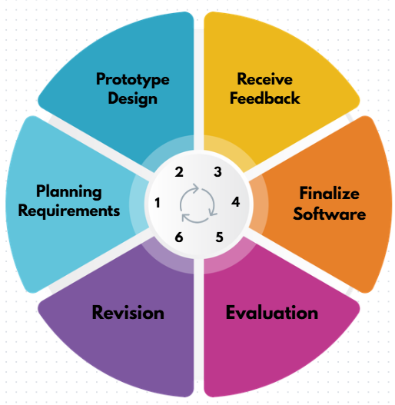
Figure 2. Agile Development Process Used in the Study
The methodology of the study consists of six major phases:
- Planning Requirements
- Prototype Design
- Receive Feedback
- Finalize Software
- Evaluation
- Revision
These phases guided the development of the proposed SaaS-based platform from requirements gathering up to system evaluation. Through this methodology, the study developed a cloud-accessible platform designed to improve the efficiency, organization, monitoring, and customer service operations of electronics repair shops in Surigao City.
- Planning Requirements
In this phase, the researcher identified the requirements needed for the proposed SaaS-based Repair Service Management Platform for electronics repair shops in Surigao City. The purpose of this phase was to determine the common problems encountered in manual repair shop operations and identify the features needed to address those problems. Since many repair shops still rely on handwritten records, notebooks, and informal monitoring of transactions, there was a need to define a system that could improve the organization and management of repair-related data.
The researcher identified the major functional requirements of the system. These include the creation and management of job orders, recording of customer and device information, updating and monitoring of repair status, technician assignment, role-based user access, technician workspace, spare parts monitoring, part request handling, payment recording, user management, report generation, and customer repair tracking using a job order number. These requirements were based on the actual workflow of repair shop operations, from device acceptance up to release of the repaired item.
Aside from functional requirements, non-functional requirements were also considered. These include usability, reliability, efficiency, security, and proper organization of records. The system was designed to be easy to use, dependable in storing and retrieving records, secure in handling user access, and efficient in helping users manage repair transactions. The identified requirements served as the basis for the prototype design and development of the proposed system.

- Prototype
Welcome page 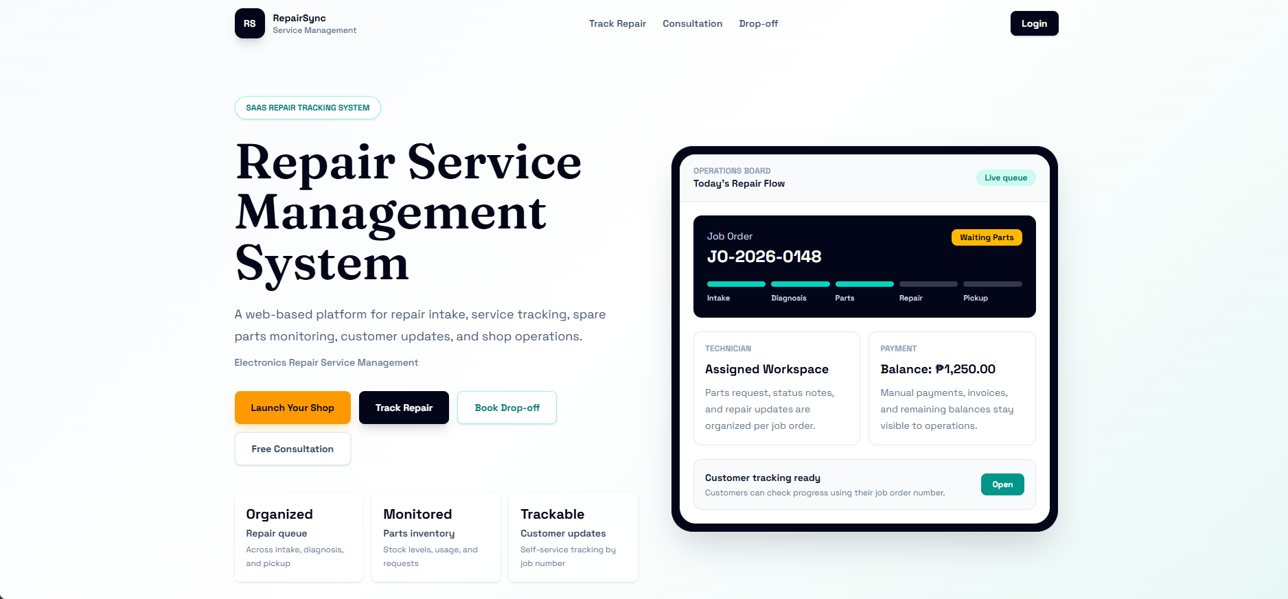
Login page 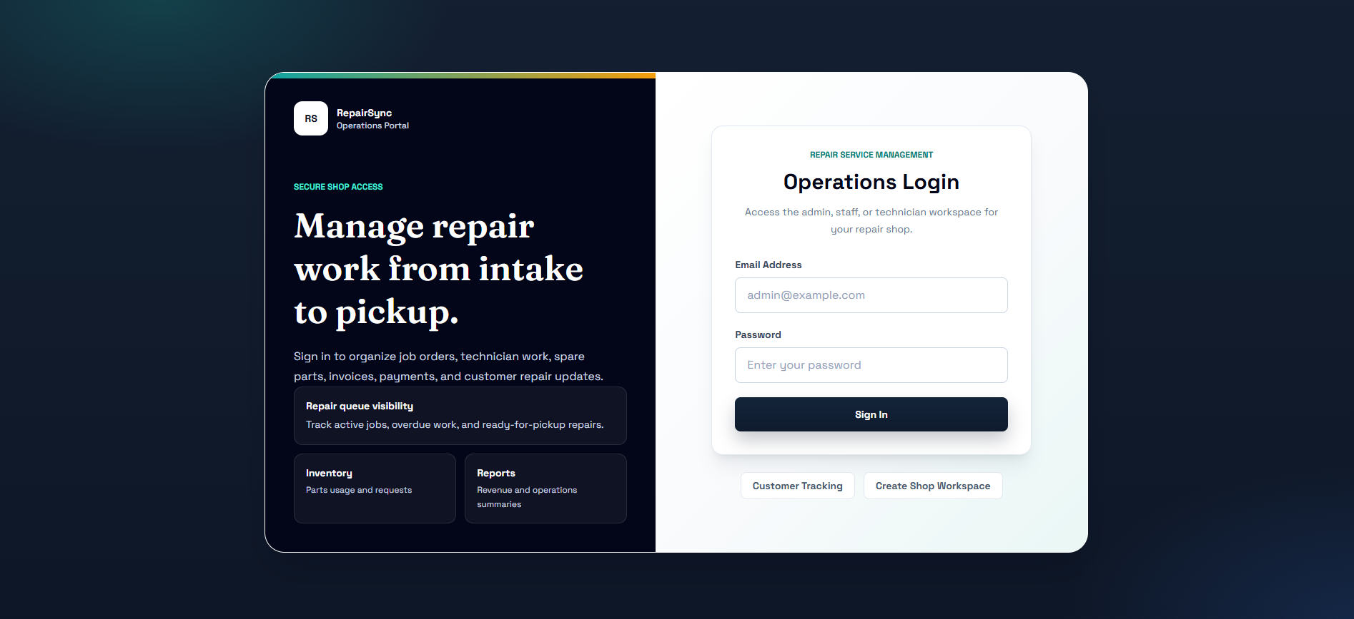
Admin Dashboard 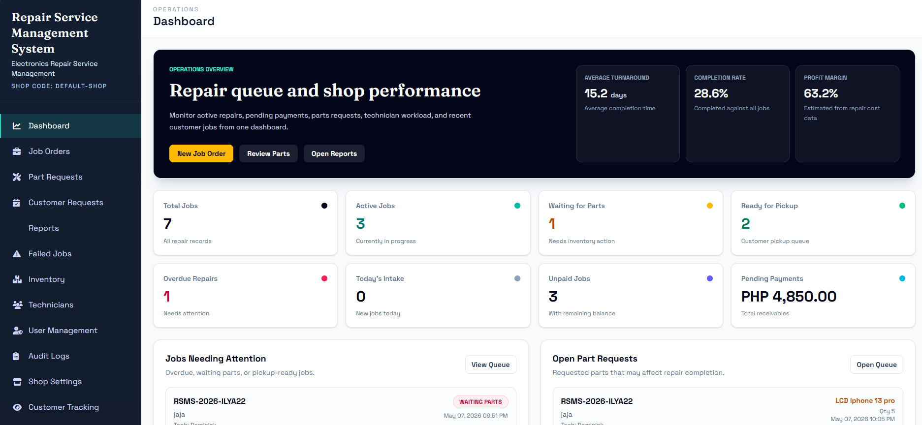
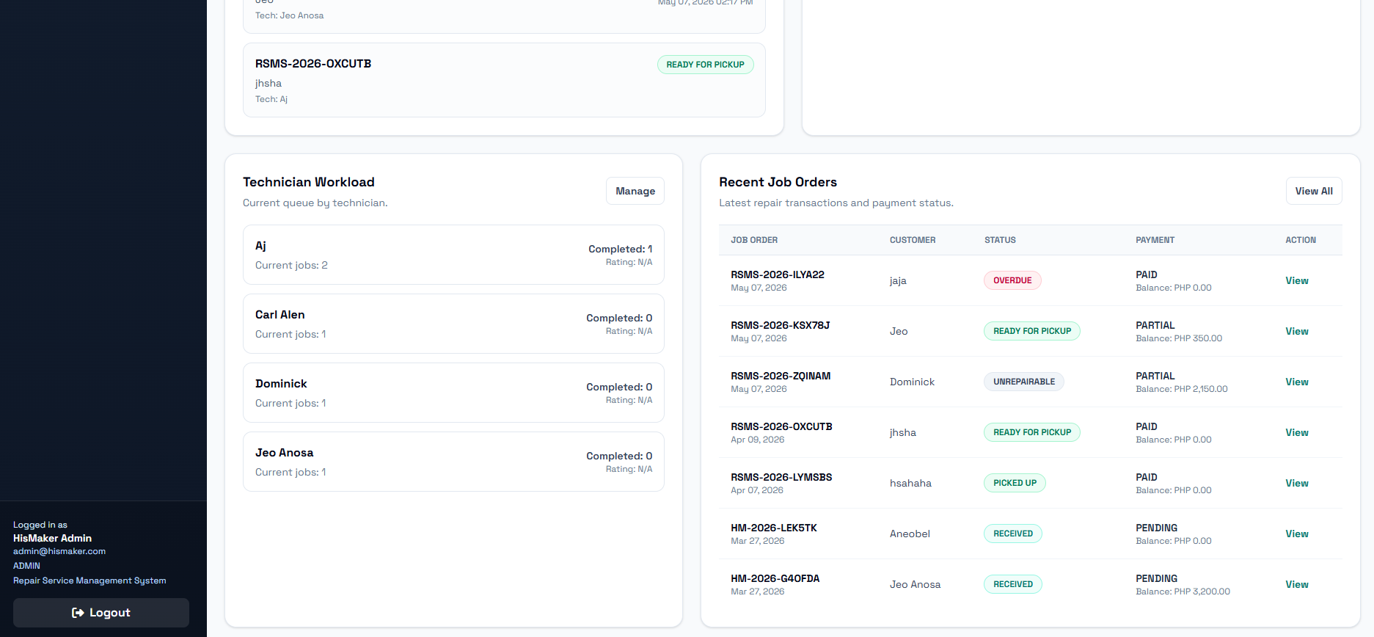
Admin/Job Orders 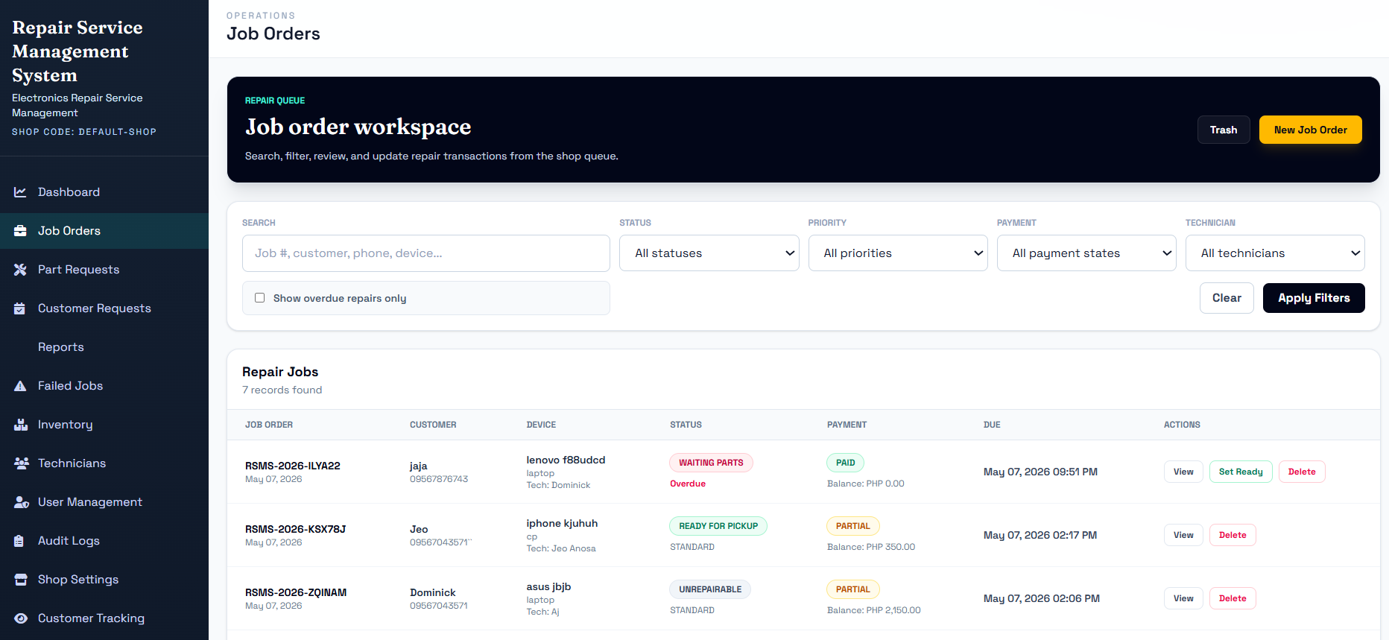
Part Requests 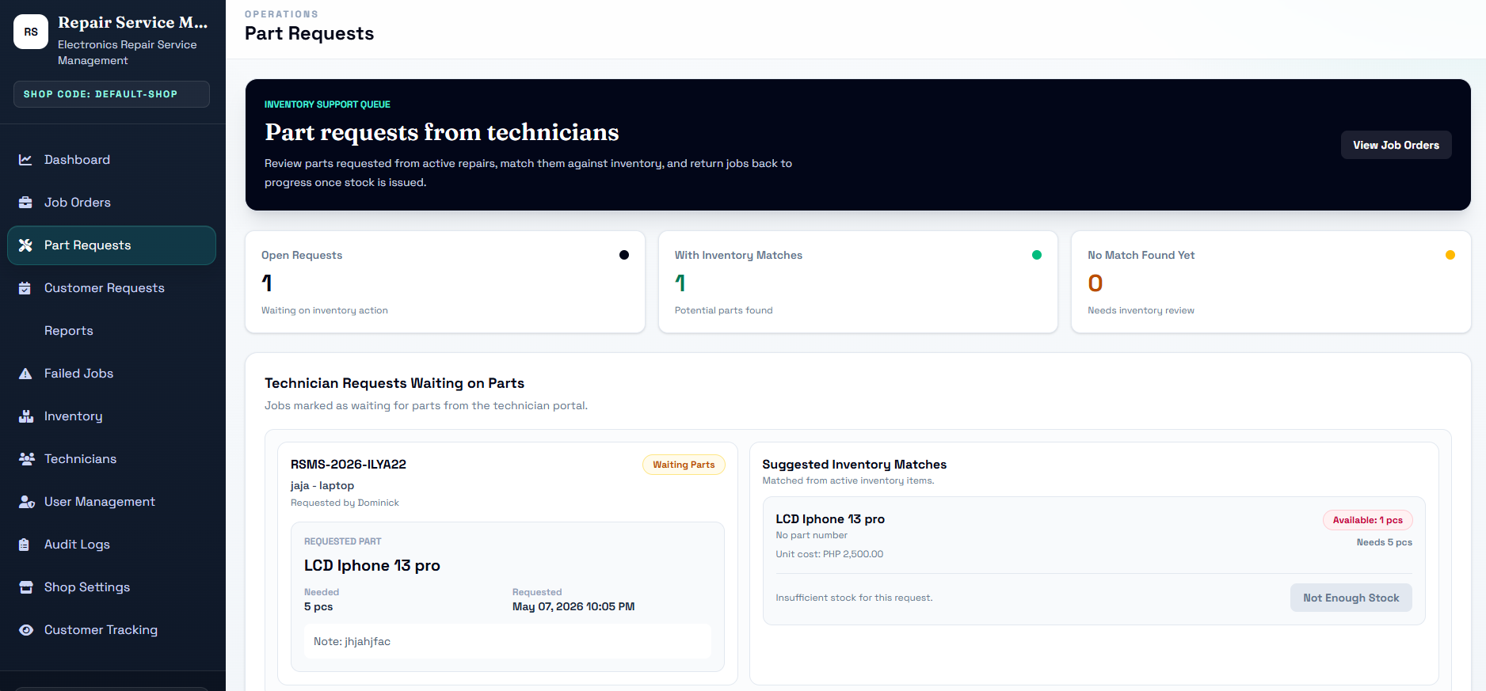
Customer Requests 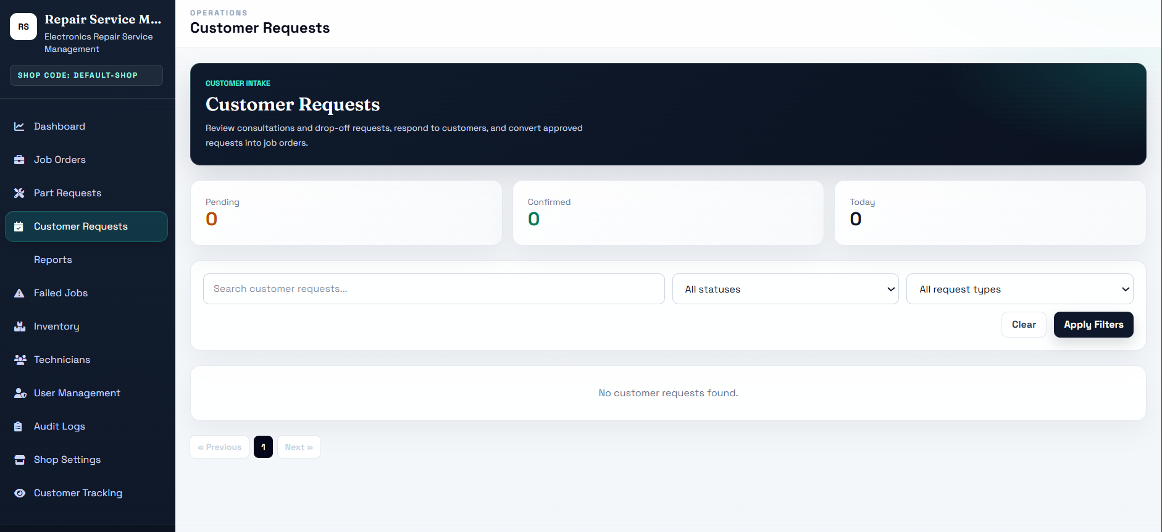
Reports 
Failed Jobs 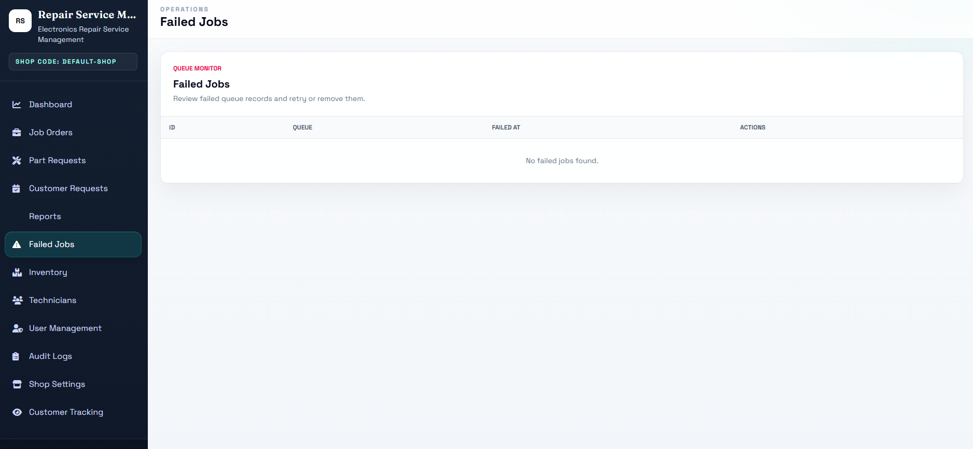
Inventory 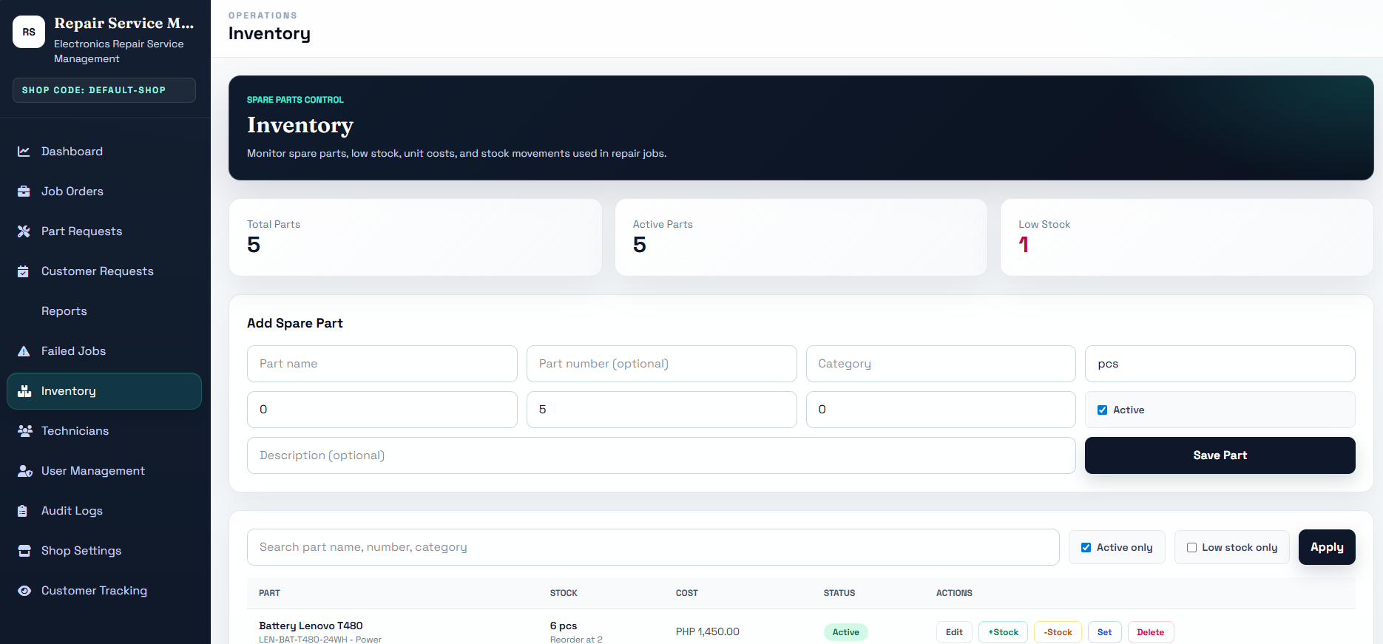
Technician 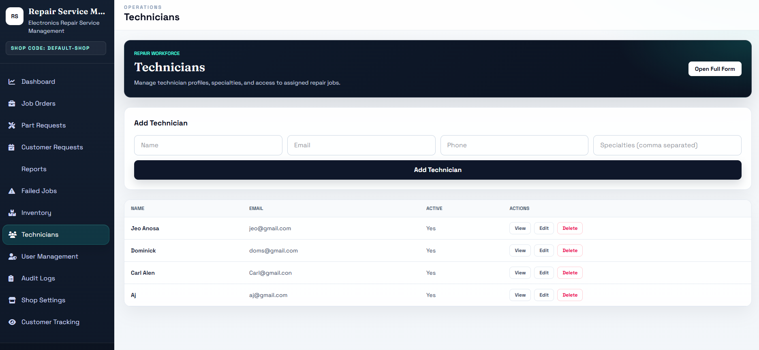
User Management 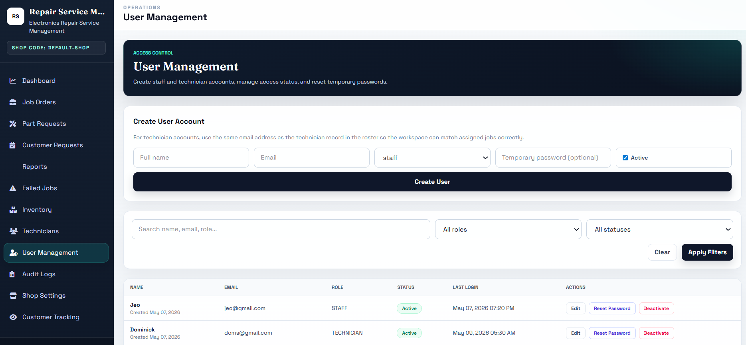
Audit Logs 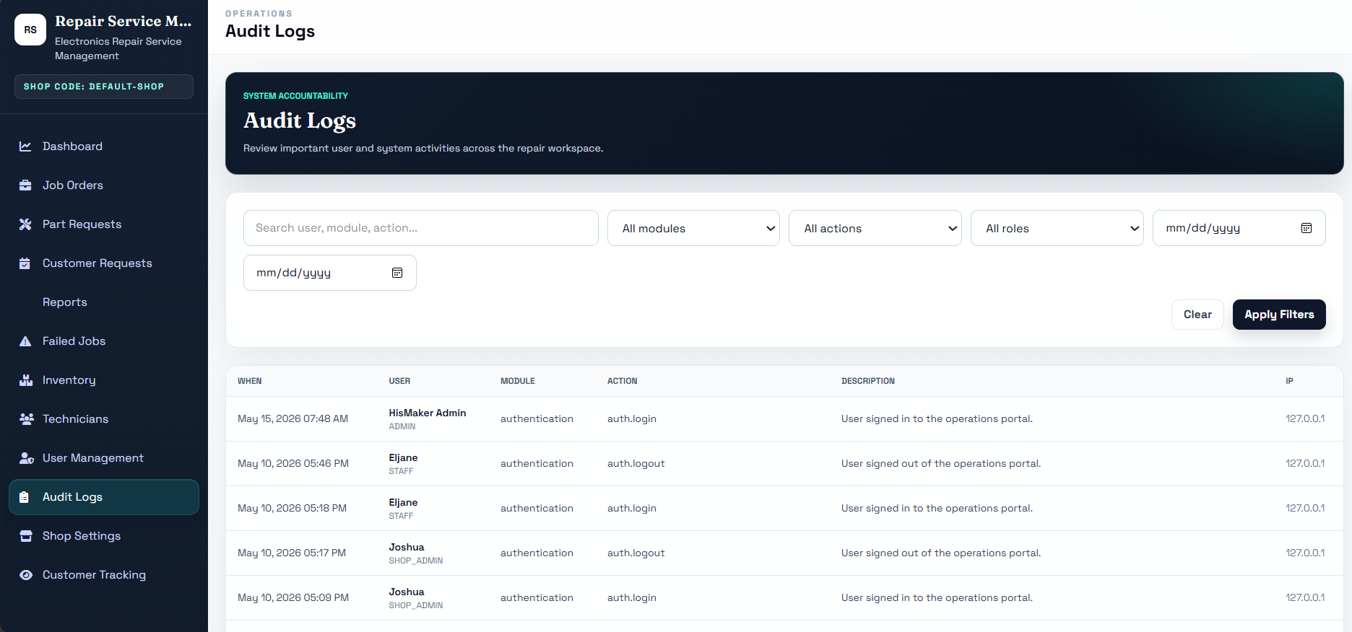
Shop Settings 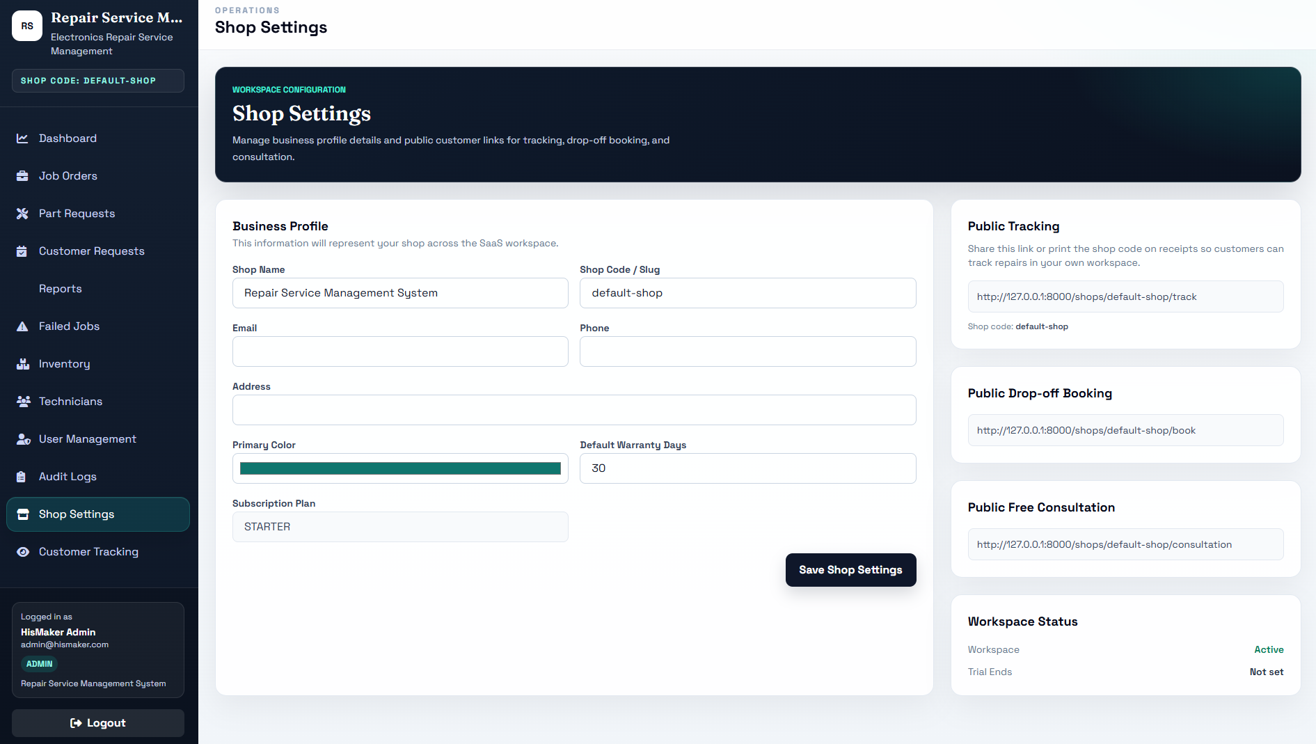
Client Side 

Track Repair
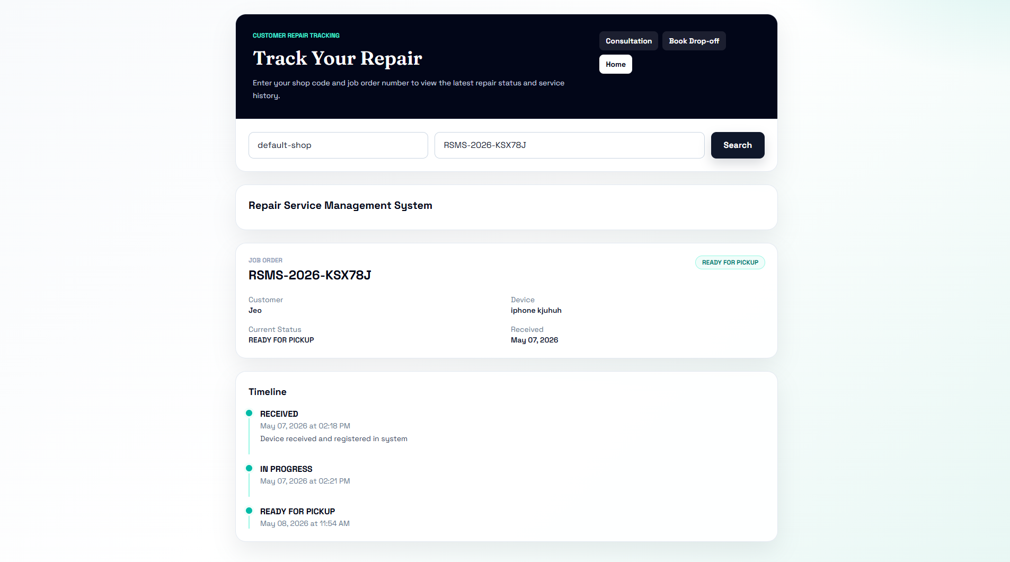

Consultation
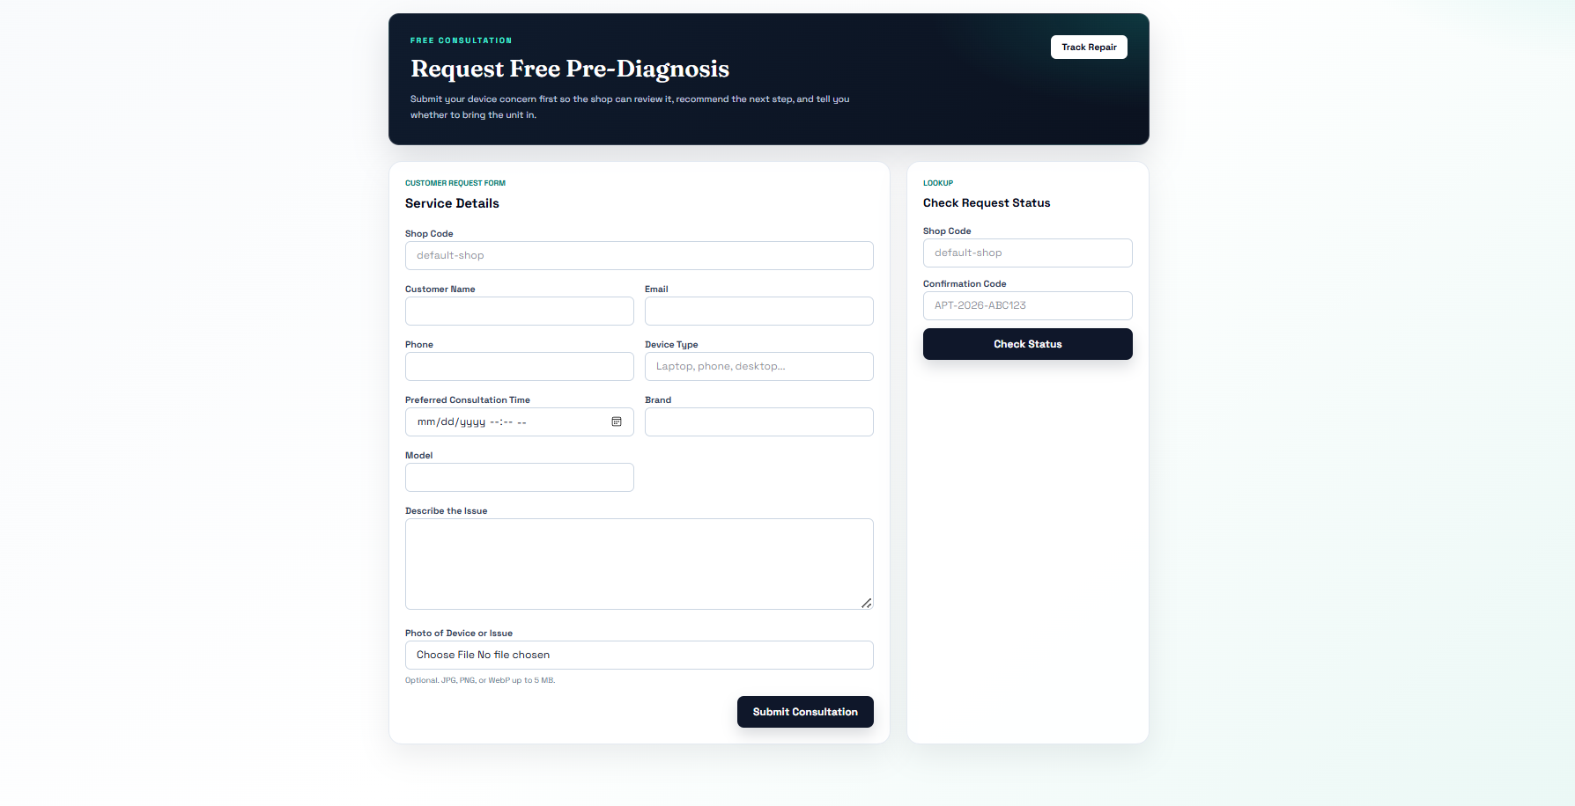
Drop-off Booking 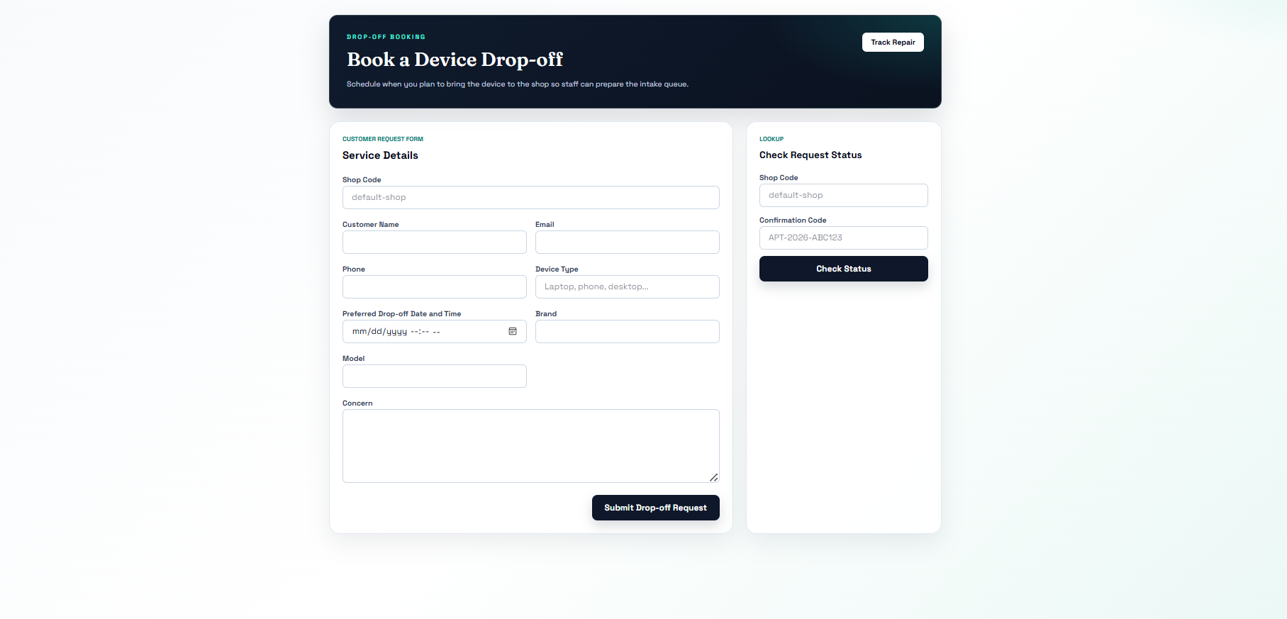
Staff Side 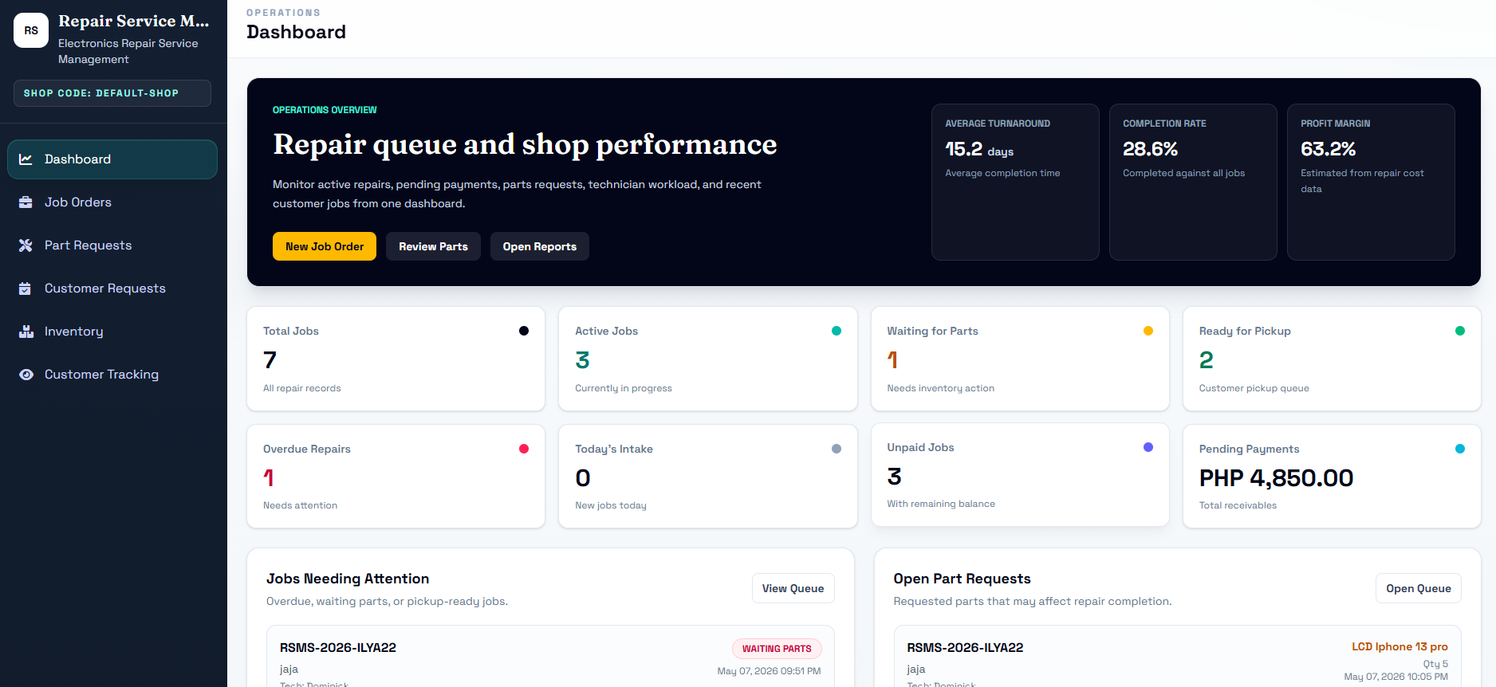
Technician Side 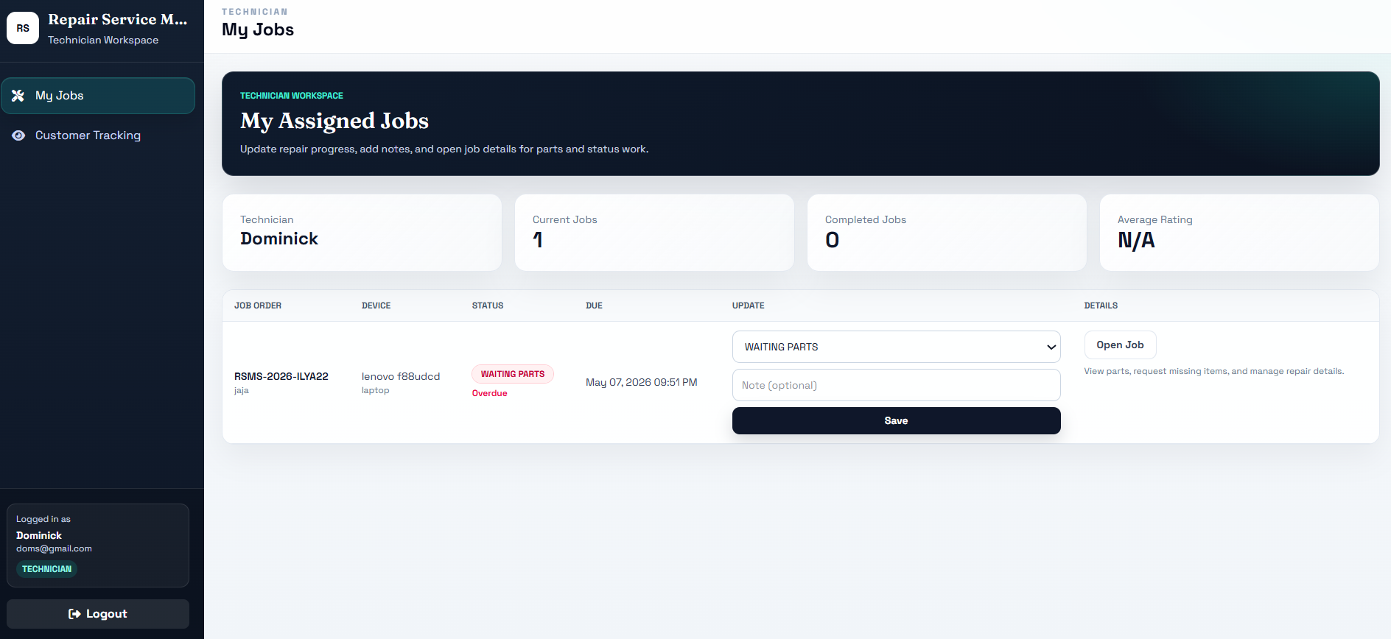
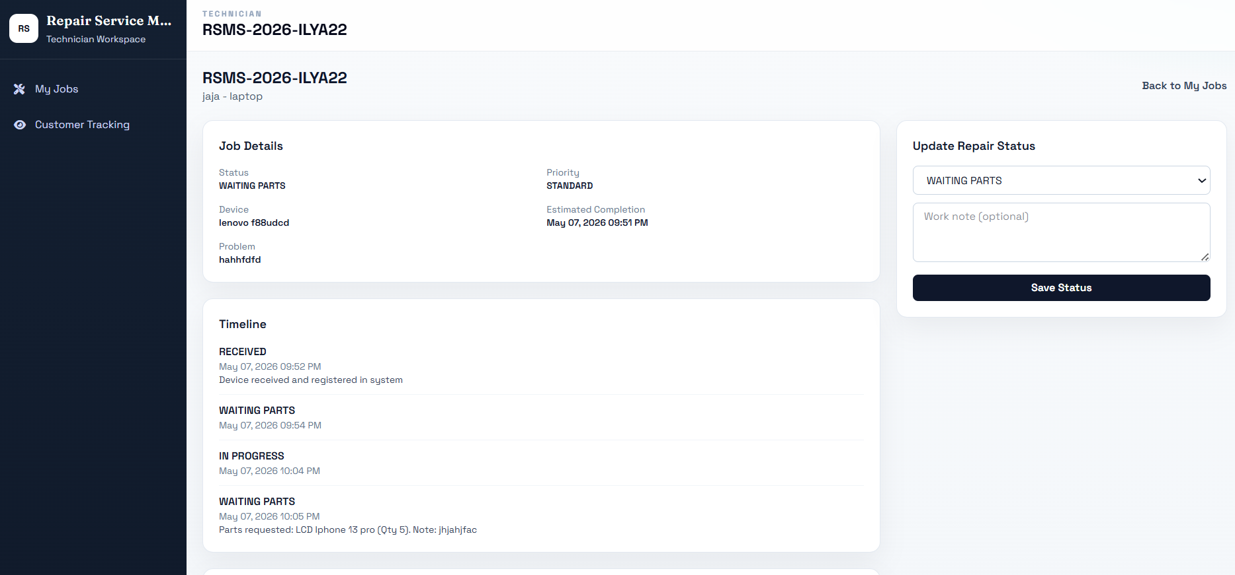
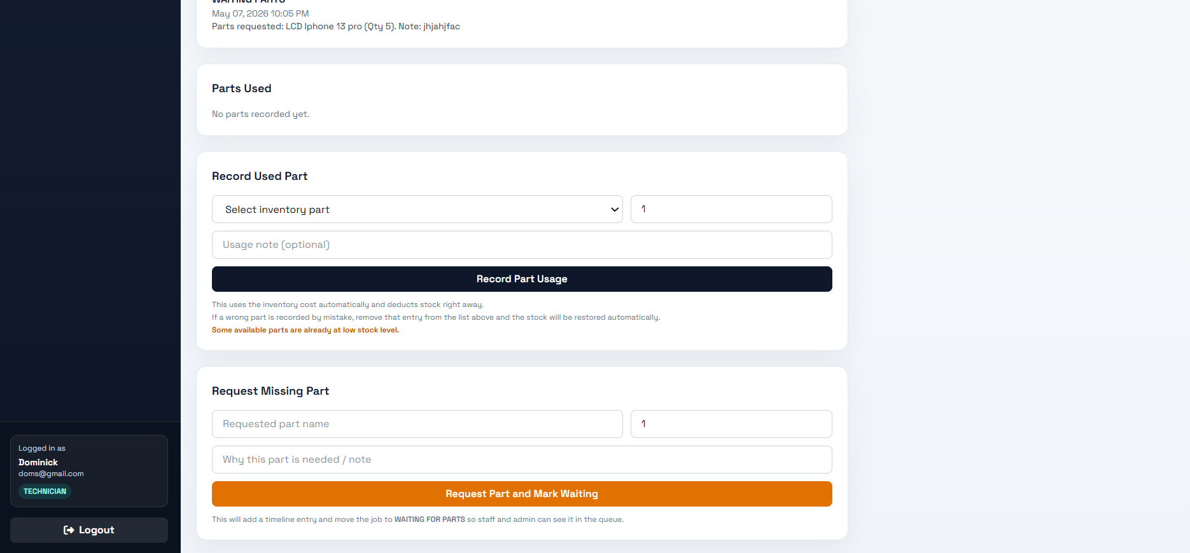
Create Shop Workspace 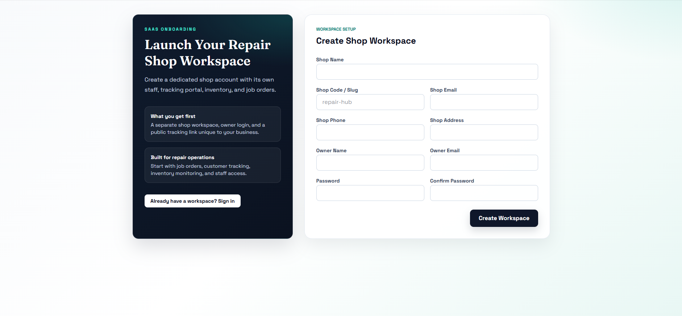

The prototype phase focused on preparing the initial design and structure of the proposed SaaS-based Repair Service Management Platform. The purpose of this phase was to provide a visual guide for how the system would appear and function before the actual development of the software.
The prototype included the major pages and modules of the system, such as the login page, dashboard, job order management page, repair status section, technician management page, technician workspace, spare parts and inventory page, part requests page, payment recording section, reports page, user management page, and customer tracking page. These initial designs were arranged according to the expected workflow of electronics repair shop operations. In this way, the researcher was able to visualize how the users would interact with the system and how the different modules would be connected.
This phase was important because it helped the researcher organize the system layout and identify possible improvements before the implementation stage. By creating the prototype first, the researcher was able to establish a clearer structure for the proposed system and reduce confusion during software development.
- Receive Feedback
The feedback phase was conducted to review the initial design of the proposed system and identify areas that needed improvement. Its purpose was to ensure that the structure, arrangement, and flow of the system were practical, organized, and aligned with the actual needs of electronics repair shop operations.
The review process focused on the clarity of the forms, the arrangement of menus, the visibility of important repair details, the flow of transaction monitoring, and the usability of role-based access for administrators, staff, and technicians. Particular attention was given to the job order module, repair status updates, technician workspace, part request handling, payment recording, inventory monitoring, and customer tracking feature, since these are among the most important parts of the proposed system. Necessary adjustments were made to improve the organization of records and make the system easier to understand and use.
Through this phase, the researcher was able to refine the initial design before moving to final development. The improvements made during this stage helped strengthen the usability and structure of the proposed system and served as a guide for the implementation of the final software.
- Finalize Software
The software development phase involved the creation of the final version of the proposed SaaS-based Repair Service Management Platform. In this phase, the planned design and identified system requirements were translated into an actual working system intended to support the daily operations of electronics repair shops in Surigao City.
The proposed system was developed using appropriate web technologies for both the frontend and backend of the application. These technologies were used to build the major modules of the system, including job order management, repair status tracking, technician assignment, technician workspace, spare parts and inventory monitoring, part request processing, payment recording, user management, reports generation, and customer repair tracking. A relational database was also used to organize and store the records needed for system operation.
Internal checking and revision were also carried out during this phase to ensure that the modules were functioning properly. Records were reviewed to determine whether data could be saved, updated, retrieved, and displayed correctly. The system was also checked to ensure that inventory was updated when parts were used, requested parts could be processed properly, and different user roles could access only the functions intended for them. This phase resulted in the completion of the proposed web-based system.
- Evaluation Method and Tools
The evaluation phase was conducted to determine the acceptability of the proposed SaaS-based Repair Service Management Platform. The evaluation focused on the major quality criteria needed to assess the effectiveness and usability of the system for electronics repair shop operations.
The proposed platform was evaluated in terms of functionality, usability, reliability, and efficiency.
- Functionality refers to the ability of the platform to perform its intended operations such as repair tracking, inventory monitoring, payment recording, notification handling, online consultation, and customer tracking.
- Usability refers to the ease of use, understandability, and user-friendliness of the platform.
- Reliability refers to the consistency and dependability of the system in storing, retrieving, and processing repair-related records.
- Efficiency refers to the ability of the platform to help users complete repair transactions and monitoring activities in a more organized and timely manner.
To evaluate the proposed system, the researcher used a survey questionnaire distributed to selected respondents composed of repair shop personnel and target users. The questionnaire gathered the respondents’ assessment of the system based on the identified evaluation criteria.
The collected responses were summarized, interpreted, and analyzed to determine the overall acceptability of the proposed SaaS-based Repair Service Management Platform.
5. RESULTS AND DISCUSSION
This chapter presents the planning and design of the proposed SaaS-based Repair Service Management Platform for electronics repair shops in Surigao City. It discusses how the project was organized during development and presents the system design through diagrams that describe the interaction of users with the system and the relationship of the major data classes. These design models serve as the foundation for understanding how the proposed system is structured and how it supports the management of repair shop operations.
The chapter focuses on project planning and system design because these are essential in showing how the system was conceptualized and prepared before full deployment. The discussion includes the development schedule, the identified system modules, and the design representations of the proposed system. Through these discussions, the chapter explains how the system is intended to provide a more organized, efficient, secure, and transparent approach to handling repair shop transactions.
- Project Planning
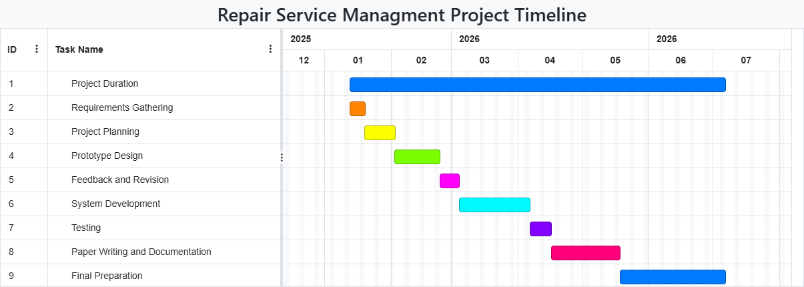
Figure 3. Gantt Chart

Project planning was conducted to organize the development process of the proposed Repair Service Management System. In this phase, the researcher arranged the major activities needed to complete the study, from the initial planning of the project up to the preparation of the system design and documentation. The purpose of this phase was to ensure that the development of the system followed a clear and systematic sequence.
The planning of the project included the identification of major modules and development tasks. These modules include job order management, repair status tracking, technician assignment, technician workspace, spare parts and inventory monitoring, part request handling, payment recording, user management, report generation, audit logging, and customer tracking. After identifying these modules, the researcher organized the activities into phases such as requirements gathering, project planning, prototype design, feedback and revision, system development, testing, and documentation.
Project planning also involved preparing a schedule of activities to guide the completion of the study. Through the timeline, the researcher was able to allocate time for each major phase of the project and maintain an organized workflow throughout development. This planning phase helped ensure that the study remained focused, manageable, and aligned with the intended objectives of the proposed system.
- System Design
System design presents the structure and interaction of the proposed Repair Service Management System. It is an important part of the study because it shows how the system was organized to support the needs of electronics repair shop operations. Through system design, the researcher is able to present the functional interaction of users with the system and the structural relationship of the major data components.
In this study, the system design is represented through the Use Case Diagram and the Diagram. The Use Case Diagram illustrates the interaction between the actors and the system by showing the major functions available to each user. The Class Diagram presents the main classes or data entities of the system together with their attributes and relationships. These diagrams provide a clearer understanding of how the system works and how its components are connected.
The system design reflects the major functions identified during the planning requirements phase. These include job order creation, repair status monitoring, technician assignment, technician job handling, spare parts and inventory management, part request handling, payment recording, user management, report generation, and customer repair tracking. By presenting these through diagrams, the study is able to provide a more organized and technical view of the proposed system.
- Use Case Diagram
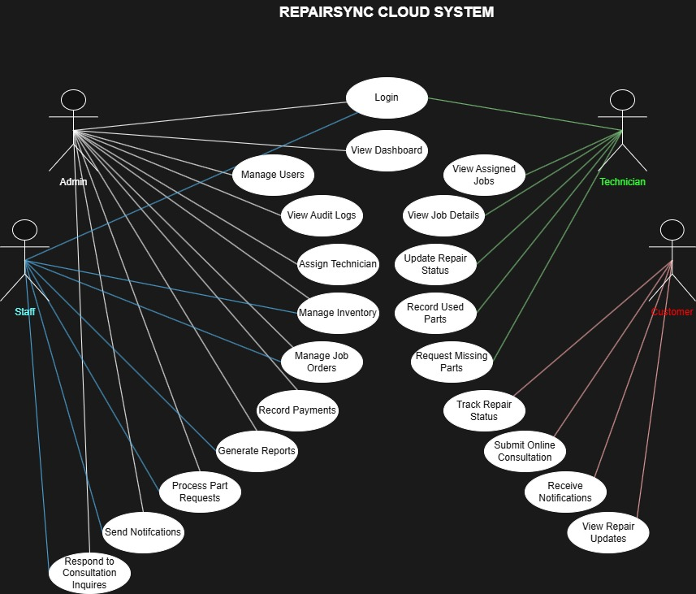

The Use Case Diagram illustrates the interaction between the users and the proposed web-based Repair Service Management System. It identifies the actors involved and the major system functions available to them. In the proposed system, the primary actors are the Administrator, Staff, Technician, and Customer.

The Administrator is responsible for managing the full operations of the system. This actor can log in to the system and perform major management functions such as managing job orders, assigning technicians, updating repair status, monitoring and managing inventory, processing payments, managing user accounts, reviewing audit logs, and generating reports.

The Staff is responsible for day-to-day repair shop operations. This actor can log in to the system and manage job orders, record customer and device information, update repair status, monitor inventory, process part requests, record payments, and restock or add inventory items based on allowed permissions. These functions help support the operational workflow of the repair shop.

The Technician interacts with the system through the technician workspace. This actor can log in to the system, view assigned jobs only, update repair status, record used parts when stock is available, and request missing parts when stock is unavailable. These functions support the actual repair process and improve coordination between technicians and staff.

The Customer interacts with the system through the repair tracking feature. The customer can use a job order number to check the current status of a repair job. This allows the customer to monitor the progress of the device without having to visit the shop or contact the staff repeatedly for updates. This feature improves transparency and helps provide better customer service.

The Use Case Diagram shows that the proposed system is designed to support both internal management functions and customer-facing tracking functions. The administrator, staff, and technician perform role-based operational tasks within the system, while the customer uses the tracking feature to monitor repair progress. This design reflects the actual workflow and intended use of the proposed system.

- Class Diagram

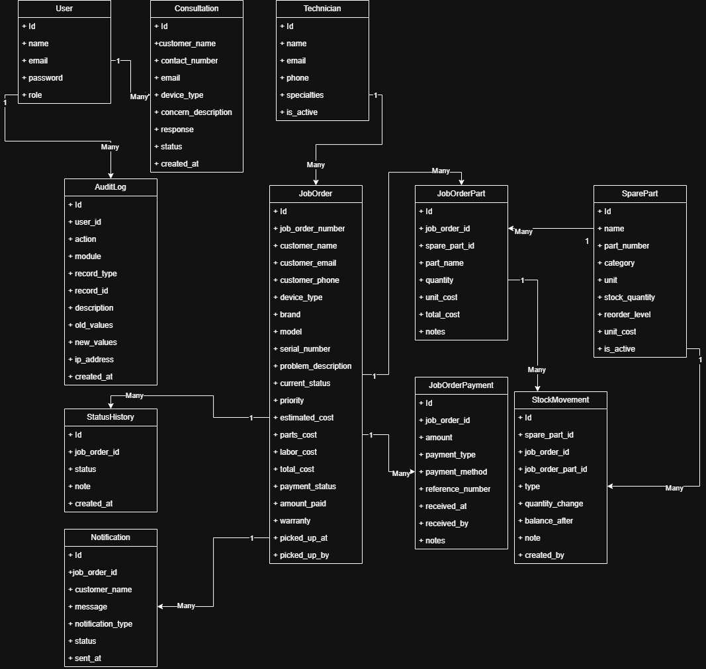
The Class Diagram presents the major classes of the proposed SaaS-based Repair Service Management Platform and the relationships among them. These classes represent the main data entities stored and managed by the system. The Class Diagram is important because it provides a structural view of the system and explains how records are connected to one another.
In the proposed system, the main classes include User, JobOrder, Technician, StatusHistory, SparePart, JobOrderPart, JobOrderPayment, StockMovement, and AuditLog. The User class represents system accounts such as administrator, staff, and technician users. It contains the information needed for authentication and role-based access. The JobOrder class is the central class of the system because it stores the main details of the repair transaction, including customer information, device information, repair concern, repair status, costs, and payment status.
The Technician class represents the assigned repair personnel connected to repair jobs. The StatusHistory class records the timeline of repair status updates and part request related actions. The SparePart class stores inventory records, while the JobOrderPart class records the parts used in a specific repair job. The JobOrderPayment class stores payment transactions connected to a job order. The StockMovement class tracks changes in inventory whenever parts are added, deducted, or adjusted. The AuditLog class stores important user and system activities for monitoring and accountability.
These classes work together to support the main operations of the system. Their relationships allow the system to maintain organized and connected records for job orders, technician assignments, repair progress, parts usage, inventory changes, payments, and user activities. Through the Class Diagram, the study presents a clear structural representation of how the proposed system manages repair shop operations.

